QP Youth Ministry
Retreat, P&T &/or Mini-Course Offerings
in the time of Corona

Please e-mail Cheryl or Sarah at least 24 hours prior to the beginning of any session to sign up for any session so we can get you resources and Zoom details.

Retreats for Lent of 2021
(It’s all about your relationship with God)

Pilgrimage Retreats will resume in the Easter Season!

We do still have spots open on our Summer Mission Trip to the Leech Lake Reservation in July and for our Disciple Camp in June.

Another late Night Overnight Option will also be available in the spring/summer.

Private/Family Retreat Options are also available
If you would like more information on what a Privately Directed Retreat would look like, please email Cheryl at cheryl.horne@qopc.org

Pizza & Theology
(All about your relationship with your church)

Tuesday, March 23, 4:30-5:30pm
Registration is required Thursday, 3/18 at 4pm so we can send you a few YouTubes to watch
These YouTube videos will be a major part of our ‘Pizza & Theology’ discussion

Thursday, April 15, 4:30-5:30pm
Registration is required Monday, 4/12 @ 4pm so we can send you a few YouTubes to watch
These YouTube videos will be a major part of our ‘Pizza & Theology’ discussion
Mini-Courses Lent of 2021
(How do we live in this world as people of faith?)

______The End of the World as We Know it?
Saturday, February 27, 2-5pm (Zoom)
(This session is on Zoom. The full session is needed for credit).

With everything that happened in 2020, it’s not surprising to hear people starting to question whether or not it’s the end of the world. But what does the Church actually teach about the end times? Do Catholics believe that Satan is a real being? What’s the deal with angels and demons? In this mini course, we’ll take a closer look at some of the most popular depictions of the end times and the spiritual realm (including things like exorcisms, angels, & ghosts!) and see how they compare to what the Church actually teaches.

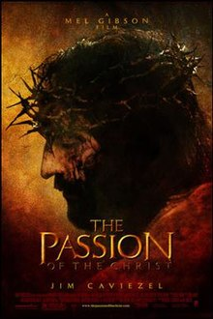
_____ The Passion of the Christ
Friday, March 5th 6-10:30pm at Our Lady Queen of Peace Parish Center
(This session is in Person session. The full session is needed for credit).
This film is rated R.
In case you’ve never seen– or if you’d like to see it again & discuss it…. (Trust me, this isn’t a movie you want to see on your own!) We’ll talk about the film, it’s impact, it’s controversy, it’s fallout and what it says about Jesus – as well as what it doesn’t say. We’ll show it projected on the Parish Center Lower Level wall – as big as we can – and we’ll unpack it & pray about it together afterwards. We’ll have cheese pizza, ‘movie munchies’ etc

_______Lenten Journey of Hope
Saturday March 13th, 3-7pm
(This session is on Zoom. The full session is needed for credit).
“Hope shines brightest in the darkness, when all seems lost.” --Bishop Hying.
This has been a challenging year, and at times it’s been difficult to stay hopeful amid so much uncertainty. But the season of Lent is a time when we as Catholics embrace a hope that triumphs over all trials - and that’s what we’re going to explore in this mini course! Using supplies from your art kit (to be delivered in advance of the course), we’ll walk back through our faith journeys highlighting the critical moments God has been present. Then, we’ll create a couple Lenten works of art to help guide the rest of our Lenten journey (and beyond!)
Please RSVP for this course no later than Wed. 3/10 at 12pm, so we can buy enough supplies for the art kits!

______ Walk the Walk and Feed My Sheep

Saturday, March 20th 8:00am-2pm OR 12:30pm-6:30pm (This session is in Person session. A full session (held at CMC off Park Street is needed for credit).

This mini-course which is also worth 2 service hours, is a collaboration between Kids Against Hunger, the Westside Catholic Youth Network, and the Catholic Multicultural Center. Together we will explore the 7 principals of Catholic Social Teaching, and then help with preparations as families gather to make meals which will then be sent out to Wisconsin food pantries in greater need than ever due to the pandemic – as well as to the farthest reaches of the world.
Please sign up for this one by March 15 so we can fill you in on location & other details!

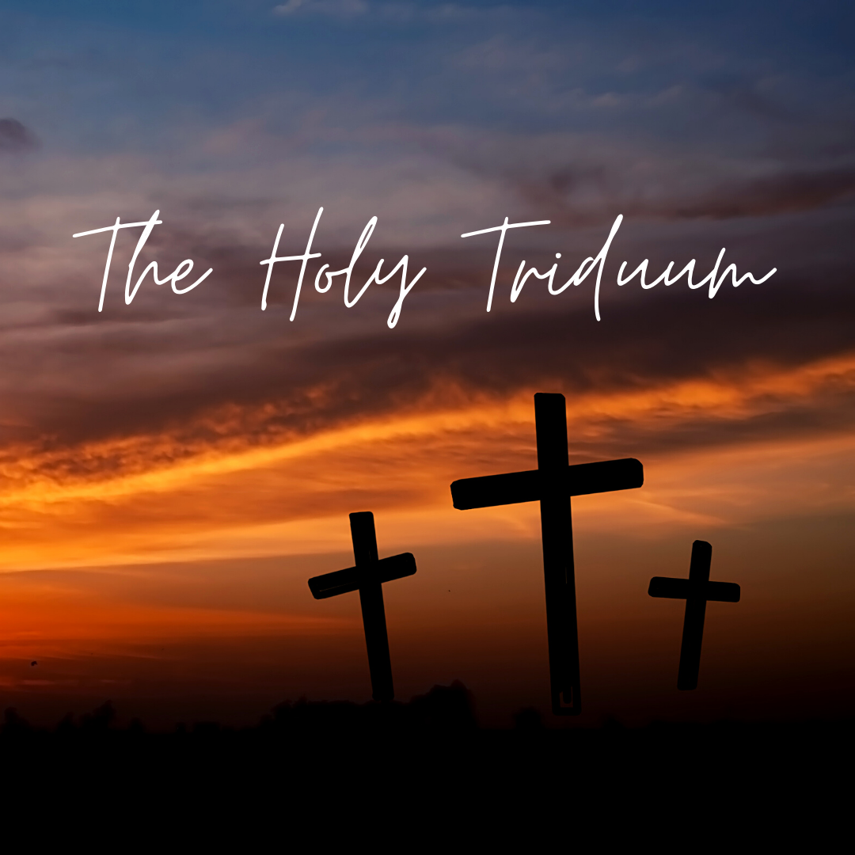
______The Holy Triduum
Thurs. 4/1, 6-8:30pm AND Fri. 4/2, 11am-2pm (Maximum room of 12 students)
(This session is in Person session. The full sessions are needed for credit).
You may have heard that the Holy Triduum (aka the three days leading up to Easter Sunday: Holy Thursday, Good Friday, and Holy Saturday) are the most sacred days of the Church year. But have you ever wondered… why? This year, enter more deeply into the Triduum than ever before! Together, we’ll watch films that bring these sacred days to life in powerful ways. Then, we’ll go participate in the liturgies together and take time to pray and discuss the meaning of these sacred days for our daily lives.

